Bryan Cabrera

4/22/2024

Module 8 Assignment

**Adding Movie:**

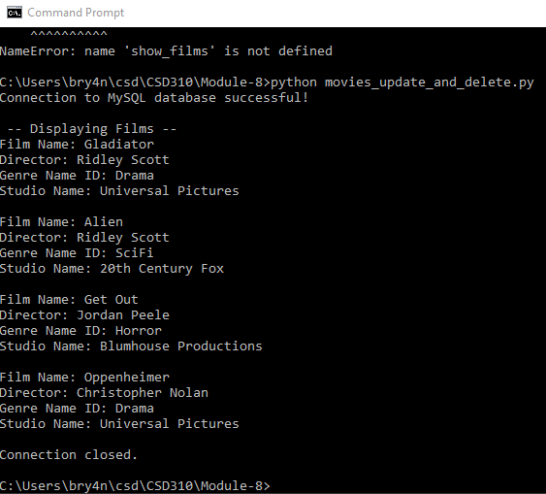

**Updating Movie:**

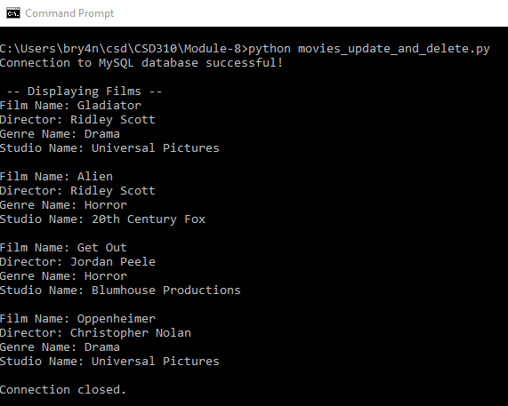

**Deleting Movie:**

